GPR acquisition in Polimi, Milano Campus

Date: December 6th, 2019

Test campaign report

Courses:

Geophysical imaging

Subsurface imaging and detection

DAN QIXUN Homework3

Homework instructions:

Please answer/comment the notes in red in the document

Objective

On December 6th we performed a GPR acquisition in the location presented in the next section in order to identify subsurface service lines (pipes, cables, tunnels).

# Description of the location

The investigated area is located on Via Clericetti, 20133 MILANO. We collected 17 X-profiles, 10 m long, with a distance between the lines of 0.25m, and 21 Y profiles, 4 m long, with a distance between the lines of 0.5m.

The following figures detail the location and the acquisition lines

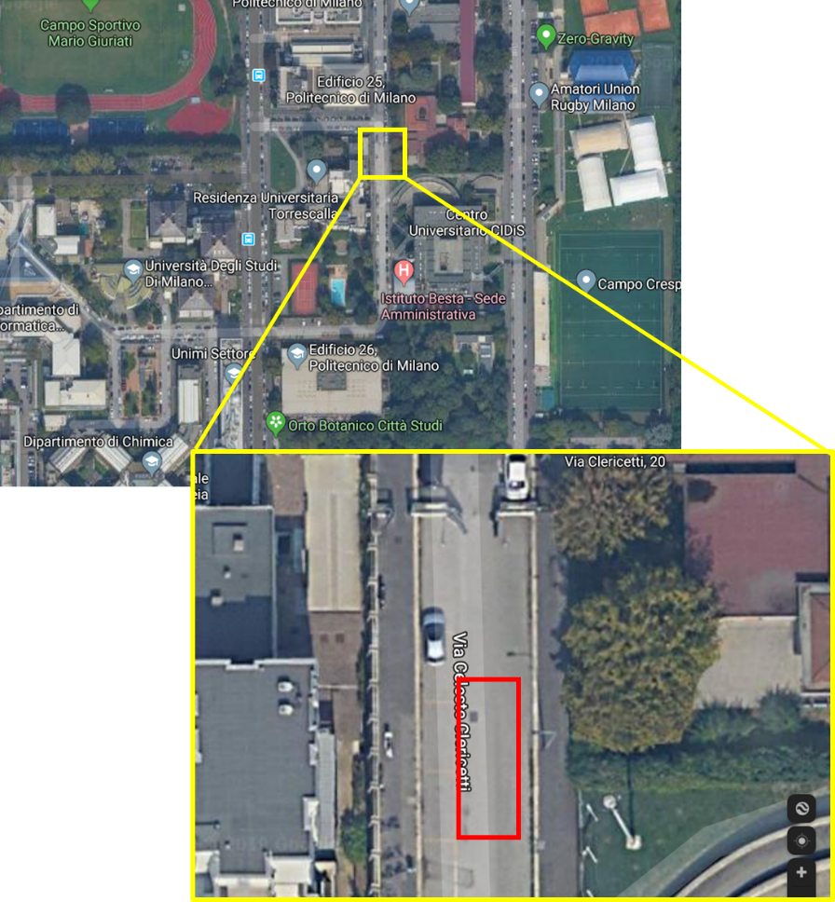

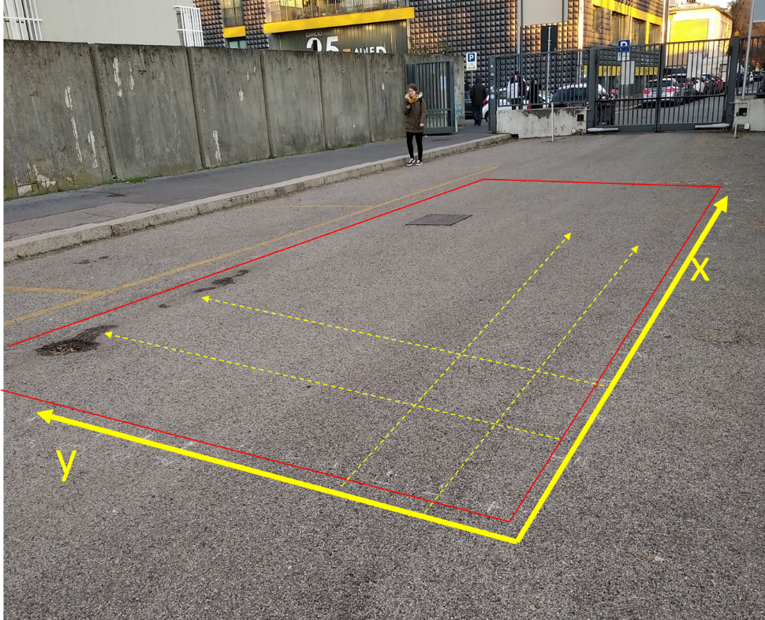

Please notice there is 1 metallic object on the surface (1 closure) that will be used as “marker” in the final result.

Please note also there are some holes in the asphalt where water can penetrate in the soil.

Homework

WHAT DOES IT HAPPEN WHEN THE GPR IS OVER A METAL SURFACE?

GPR cannot penetrate metal. Metal is highly conductive, so the radar wave cannot enter it. Almost all the energy is reflected. On the radargram, we can see very strong reflections and no information or date below the metal. If the target is a pipe, it appears as clear hyperbolas.

WHAT IS THE EFFECT OF THE PRESENCE OF WATER IN A GPR ACQUISITION?

Water increases the dielectric constant and, more importantly, the conductivity. Higher conductivity reduces the skin depth, so the penetration depth becomes smaller and the signal attenuates faster. (Higher conductivity = stronger attenuation = less penetration depth.) Therefore, in wet zones, the data are shallower and weaker.

# Equipment

We used a Detector Duo from Ingegneria dei Sistemi (IDS). It is a dual antenna system, one at 250MHz, the other at 700Mhz.

|  |  |
| --- | --- |
|  | * DAD DECT DUO Control unit(1). * Two wheeled trolley used to move the system (2). * Power cable (3). * Inverted network cable (4). * Antenna Box - Control Unit connection cable (5). * Position sensor connection cable (6). * Position sensor (7). * Detector Duo Antenna (8). * 12V lead battery (9) . * Notebook computer (10). |



Homework 3

FIND SOME INFO ABOUT THE NEW VERSION OF DETECTOR DUO IN (The name is Opera XR now)

<https://idsgeoradar.com/products/ground-penetrating-radar/opera-duo>

The newer model in this product line is Opera XR. The advanced dual antenna GPR solution for an easy utility detection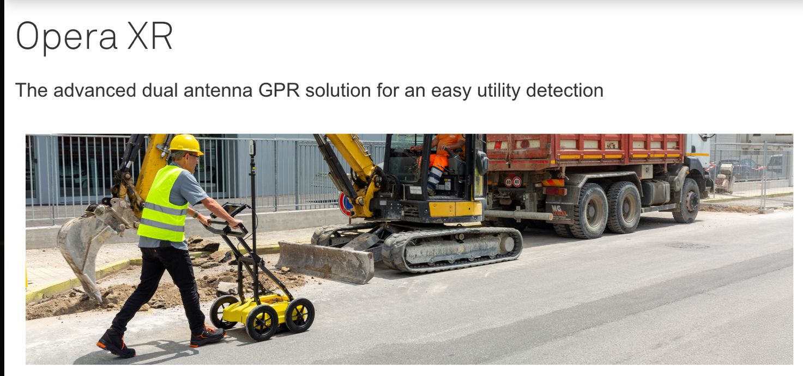

**It is a dual-antenna GPR with 200 and 900 MHz center frequencies and an inspection range of 80–1500 MHz.**

Opera XR is the compact, easy to transport and deploy dual-antenna GPR system for fast and accurate underground asset detection; featuring the new radical Equalized scrambled Technology - EsT by IDS GeoRadar, Opera XR easily brings underground assets detection to the deepest and clearest level.

It uses IDS’s patented EsT technology, which increases penetration by about 40–60% and gives clearer data compared to traditional units.

The system is compact (about 20 kg), foldable, IP65-rated, and supports hot-swap batteries for up to 8 hours of work. It also offers HH/VV polarization, encoder/GPS/TPS positioning, and a modern workflow with uMap for acquisition (real-time time-slices, on-site reporting) and IQMaps for advanced processing and cloud export.

**Benefits:**

**Revolutionary EsT technology:** for an unparalleled control of the GPR signal, extended depth range and ultra-high resolution;

Streamlined field operations with the **“Quick Scan Mode”** saving time and reducing costs;

**Simplified detection workflow:** easy deployment and set-up for single user with a higher productivity;

**Designed for ergonomics:** lightweight, compact and foldable. The height-adjustable antenna mounting system allows for a superior performance across urban scenarios;

**Easy polarization switch** of the antenna from HH to VV with a simple move;

**Non-Stop Performance:** Hot swap technology for power supply enables uninterrupted data acquisition.

**Software:**

Opera XR employs the latest software technology solutions for data collection and post processing: **uMap** and [**IQMaps**](https://idsgeoradar.com/products/software/iqmaps).  
The on-field software **uMap**, allows for faster collection and improved management of data with an easy-to-use interface that even unskilled users can comfortably manage.

[**IQMaps**](https://idsgeoradar.com/products/software/iqmaps) is IDS GeoRadar’s post-processing software application for the advanced analysis of GPR data, enabling fast interfacing between the user and GPR data itself.

**Equalized Scrambled Technology (EsT):**

How it works:

This new disruptive technology pioneers a new generation of radars allowing to exceed the performance of any other antenna and **achieves unprecedented penetration depths in underground surveying**. EsT offers the **highest detection capability ever by performing hardware equalization that brings out the deepest signal at the same level as shallow targets**. Thanks to the **noise rejection**, both the **clarity of shallow targets and high penetration depth are achieved**. After equalization, the data is 'scrambled' together **into a single radar trace, providing an extended depth range and an ultra-high resolution.**

with EsT, surface and deep reflections **are equalized with an optimal multi-gain boost** and the resulting dynamic range is incredibly extended offering the highest survey capability ever.

WHAT IS THE ADVANTAGE OF HAVING TWO PAIRS OF ANTENNAS AT DIFFERENT FREQUENCIES?

Low frequency gives deeper penetration but lower resolution.

High frequency gives higher resolution but shallow depth.

Thus operating frequency is always a trade-off between resolution and penetration.

Using both gives a multi-scale view, better reliability.

Two different frequencies give me two scales of information. The low-frequency pair penetrates deeper but has lower resolution. The high-frequency pair has higher resolution but shallow penetration. By combining the two datasets, I balance penetration and resolution, adapt to variable soils subsurfaces, and make more reliable underground mapping.

# GPR: theory short notes

Homework 3

READ AND COPY HERE THE INTRODUCTION OF

<https://en.wikipedia.org/wiki/Ground-penetrating_radar>

Ground-penetrating radar (GPR) is a geophysical method that uses radar pulses to image the subsurface. It is a non-intrusive method of surveying the sub-surface to investigate underground utilities such as concrete, asphalt, metals, pipes, cables or masonry.[1] This nondestructive method uses electromagnetic radiation in the microwave band (UHF/VHF frequencies) of the radio spectrum, and detects the reflected signals from subsurface structures. GPR can have applications in a variety of media, including rock, soil, ice, fresh water, pavements and structures. In the right conditions, practitioners can use GPR to detect subsurface objects, changes in material properties, and voids and cracks.[2][3]

GPR uses high-frequency (usually polarized) radio waves, usually in the range 10 MHz to 2.6 GHz. A GPR transmitter and antenna emits electromagnetic energy into the ground. When the energy encounters a buried object or a boundary between materials having different permittivities, it may be reflected or refracted or scattered back to the surface. A receiving antenna can then record the variations in the return signal. The principles involved are similar to seismology, except GPR methods implement electromagnetic energy rather than acoustic energy, and energy may be reflected at boundaries where subsurface electrical properties change rather than subsurface mechanical properties as is the case with seismic energy.

The electrical conductivity of the ground, the transmitted center frequency, and the radiated power all may limit the effective depth range of GPR investigation. Increases in electrical conductivity attenuate the introduced electromagnetic wave, and thus the penetration depth decreases. Because of frequency-dependent attenuation mechanisms, higher frequencies do not penetrate as far as lower frequencies. However, higher frequencies may provide improved resolution. Thus operating frequency is always a trade-off between resolution and penetration. Optimal depth of subsurface penetration is achieved in ice where the depth of penetration can achieve several thousand metres (to bedrock in Greenland) at low GPR frequencies. Dry sandy soils or massive dry materials such as granite, limestone, and concrete tend to be resistive rather than conductive, and the depth of penetration could be up to 15 metres (50 ft). However, in moist or clay-laden soils and materials with high electrical conductivity, penetration may be as little as a few centimetres.

Ground-penetrating radar antennas are generally in contact with the ground for the strongest signal strength; however, GPR air-launched antennas can be used above the ground.

Cross borehole GPR has developed within the field of hydrogeophysics to be a valuable means of assessing the presence and amount of soil water.

# Processing steps

The following figures show the processing steps for an x-profile with the low frequency antenna (250MHz). Left is initial data, right after processing.

Background removal through trace average and subtraction

Processing -> 2D filter -> Background removal

Homework 3

WHAT IS IT THE BACKGROUND NOISE?

Background noise is any unwanted signal that does not come from subsurface targets. In GPR it is produced by changes in antenna–ground distance on rough surfaces, different surface conditions (for example ruts or compacted tracks), external electromagnetic fields, and instrument noise or instabilities. These effects create bands or clutter on the radargram and reduce data quality.

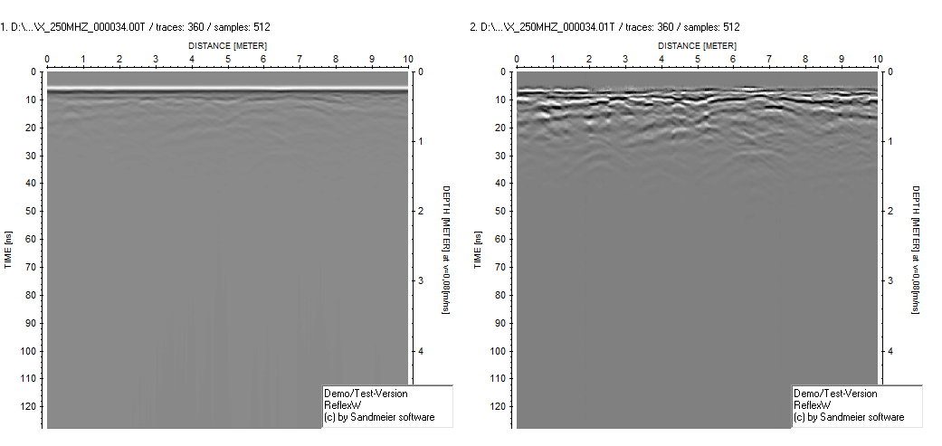

Bandpass filtering

Processing -> 1D filter -> bandpassfrequency

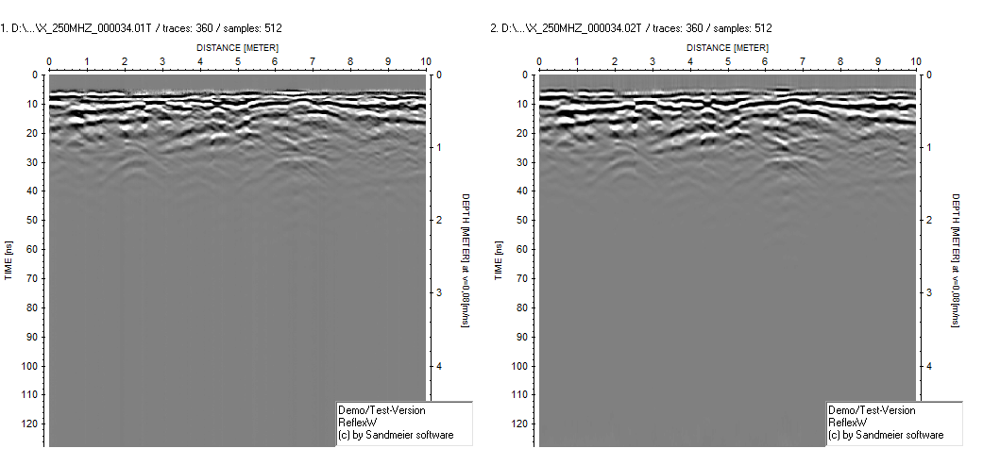

Homework 3

WHY DO WE NEED TO PERFORM A GAIN RECOVERY?

Because radar amplitudes decay strongly with time and depth. Deep reflections become too weak due to geometric spreading, absorption and scattering. Gain recovery (energy compensation) applies a time-varying boost to make late-time signals visible. In practice, we do it after background removal and band-pass filtering (Processing → Gain → energy decay). It improves deep visibility, but we must tune the window to avoid over-amplifying noise.

Gain recovery (energy compensation)

Processing -> Gain -> energy decay

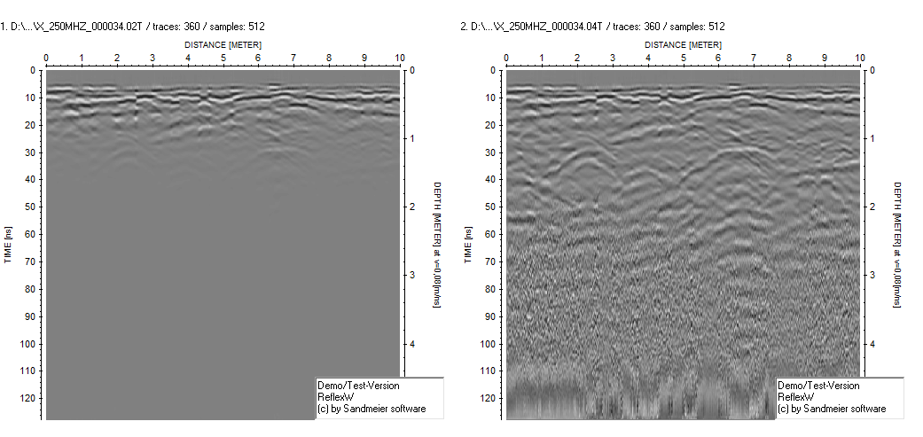

Move startime to t=0

Processing -> Static correction-> move startime

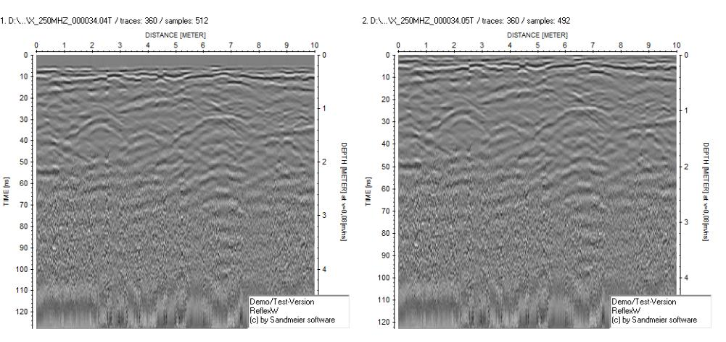

Velocity analysis

Press V button and then D (diffraction)

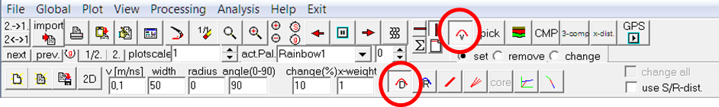

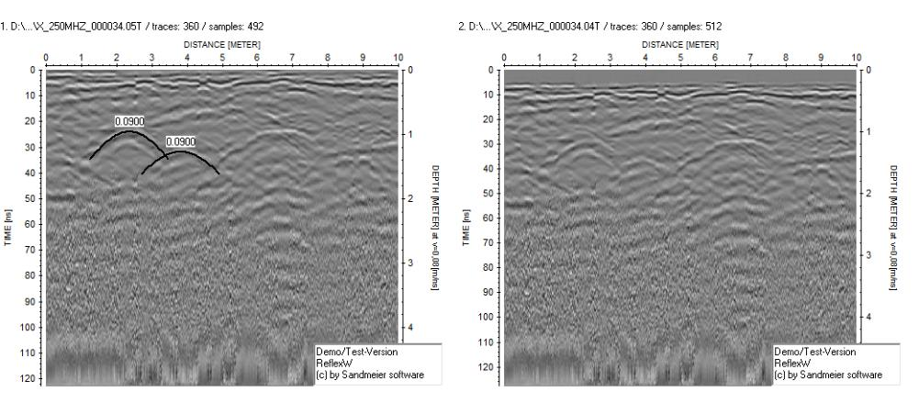

Homework 3

WHAT INFORMATION CAN WE OBTAIN FROM HYPERBOLIC “EVENTS”

A hyperbola is produced by a **point-like diffractor** (e.g., pipe, stone, edge).

By **fitting the hyperbola** (ReflexW: press **V** then **D**), we can estimate the **EM velocity** v in the ground.

From the **apex two-way time** t_0 and the velocity, we get the **depth**: z = v * t_0/2. The **apex position** gives the **lateral location** of the object under the profile.

Hyperbolas come from point targets. When I fit a hyperbola, I obtain the ground velocity. Using the apex time and that velocity, I calculate the target depth z = v * t_0/2. The apex position gives the lateral location. Then I use this velocity for migration to collapse the hyperbola to a point and place the object correctly, improving the true position of targets.

Migration

Processing -> Migration-> diffraction stack

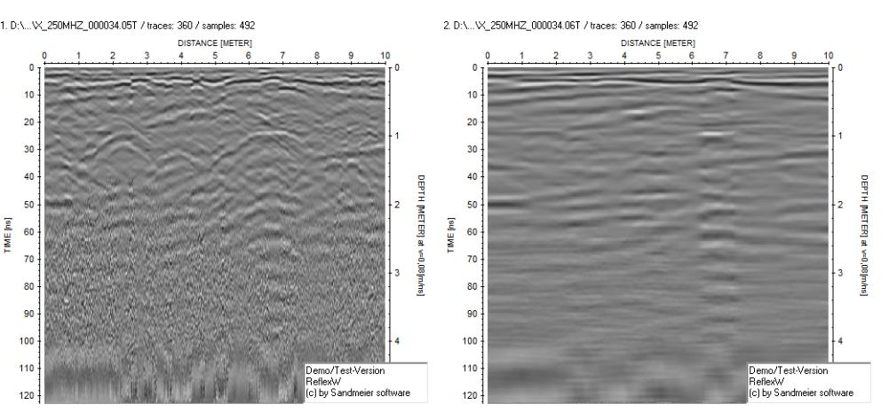

List of processing steps:

file: PROJDIR\ PROCDATA\X_250MHZ_000034.00T

fix profile length / 10 / 0 / 0 / 0 / / 0 / 0 / 1 / 386

background removal / 0 / 127,75 / 0 / 9,99456 / / 0 / 0 / 1 / 360

bandpassfrequency / 50 / 90 / 400 / 800 / / 0 / 1 / 1 / 360

AGC-Gain / 20 / 1 / 10000 / 32000 / / 0 / 1 / 1 / 360

move starttime / -5 / 0 / 0 / 0 / / 1 / 1 / 1 / 360

diffraction stack / 40 / 0,9 / 0 / 122,75 / / 0 / 45 / 1 / 360

# 3D reconstruction

The 17 x-profiles for the 250Mhz antennas have been processed with the same processing flow. The migrated gather for each line has been merged in a 3D volume. Here we show some “slices” of the volume

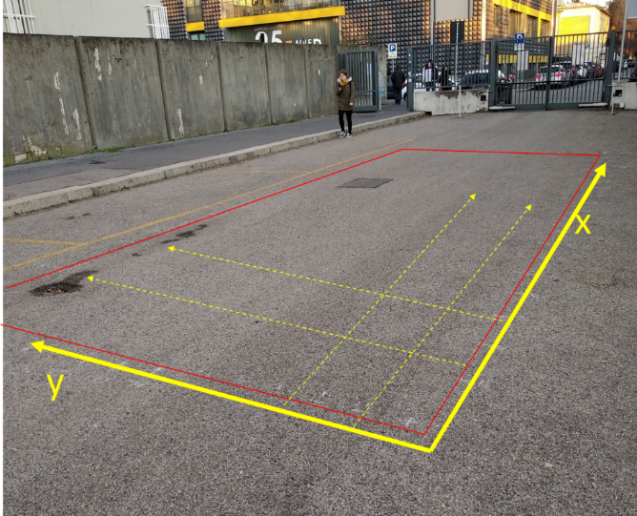



|  |  |
| --- | --- |
| Slice at 20cm from the surface (gray scale).  Visible the metal surface. |  |

|  |  |
| --- | --- |
| Slice at Slice at 20cm from the surface (colors).  Visible the metal surface. |  |

|  |  |
| --- | --- |
| WET SOIL?  X and Y profiles processed together. Slice at 20cm from the surface (colors). |  |

# Conclusion

The GPR can be used to map service lines

The conductivity of the media affects the depth of investigation, having low penetration for high conductivity: this is evident over metal surfaces